FOL, Resolution, Forward and backward chaining

1.

Write first order logic statements for following statements:

(i) Horses, cows, and pigs are mammals.

(ii) Bluebird is a horse.

(iii) Whoever can read is literate.

(iv) Every tree in which any aquatic bird sleeps is beside some lake.

(v) Anything anyone eats and is not killed by is food.

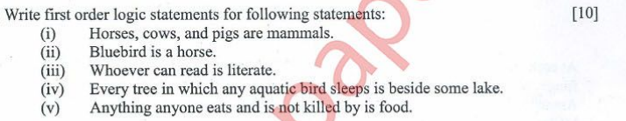

2.

Convert the following English sentence into predicate logic and then into CNF

“The culprit was tall and dark"



3.

Write first order logic equivalent of the following statements:

(i) Anand likes only comedy films.

(ii) The culprit has to be one from Tinker, Tailor and Butler.

(iii) Whoever can read is literate.

(iv) Every child loves Santa.

(v) Some birds cannot fly.

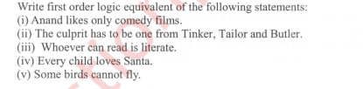

4.

What is FOPL? Represent the following sentences using FOPL

i) John has at least two friends

ii) If two people are friends then they are not enemies.

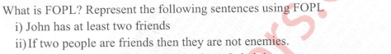

5.

Consider the following set of sentences

a) Whoever can read is literate

b) Birds are not literate

c) Some birds are intelligent

Prove the following using forward reasoning “Some who are intelligent

cannot read"

